Project Executable Files

Date | 15 July 2026
Team ID | XXXXXX
Project Name | FloodGuard - AI/ML Flood Prediction System
Maximum Marks | 3 Marks

Step 1: Submission Checklist
S.No | Item to Submit | Submitted (Yes/No/NA)
1 | Complete source code (all files and folders) | Yes
2 | README / Setup Guide (instructions to run the project) | Yes
3 | requirements.txt / dependency file | Yes
4 | Database schema / seed files (if applicable) | Yes (app/models.py, app/seed.py)
5 | Environment configuration file (.env.example or similar) | NA (no secrets required for base functionality)
6 | Deployed application URL (if hosted) | Yes
7 | APK / Executable binary (if applicable) | NA (web application)
8 | Dockerfile / Containerization config (if applicable) | NA (deployed directly via Render buildpacks)
9 | Test files and test results | Yes (Performance Testing document)
10 | Demo video or walkthrough (if required) | To be added

Step 2: File / Folder Structure
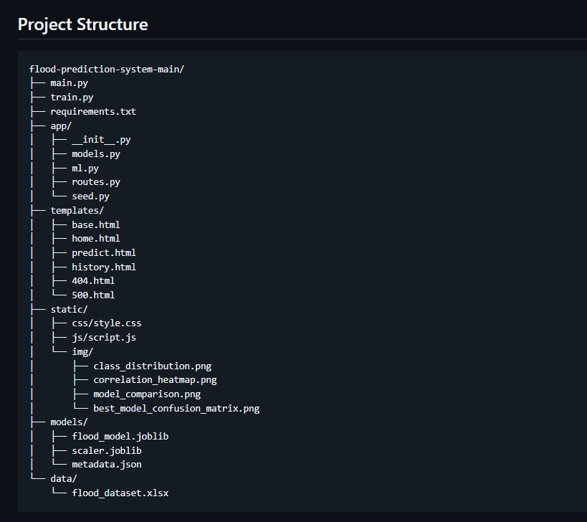

Step 3: Deployment / Access Details
Field | Details
Hosted / Deployed URL | https://floodguard-ytqr.onrender.com
Login Credentials (Demo) | Not required — the prediction form is publicly accessible
Platform / Hosting Provider | Render (Web Service, Free Plan)
Repository Link | https://github.com/BSG8710/flood-prediction-system
Demo Video Link | To be added

Step 4: Run Instructions
- Clone the repository: git clone https://github.com/BSG8710/flood-prediction-system
- Create and activate a virtual environment (python -m venv venv)
- Install dependencies: pip install -r requirements.txt
- Train the model: python train.py
- Run the app: python app.py
- Open http://localhost:5000 in a browser
Step 5: Known Issues / Limitations
S.No | Known Issue / Limitation | Workaround / Status
1 | Render free tier spins down after 15 min idle (~60s cold start) | Acceptable for demo use; upgrade to paid tier to remove
2 | Prediction history resets on redeploy (SQLite on ephemeral disk) | Planned: migrate to Render's free PostgreSQL for persistence
3 | Small training dataset (115 rows, imbalanced) | Mitigated with class-weighting and F1-based model selection

